## Strongly Connection Components

*Description:*

*The Strongly Connection Component is an utilization of Depth First Search Algorithm. Depth First Search Algorithm can be used to decompose Directed Cyclic Graph into the Strongly Connection Components.*

This chapter would introduce how to use the Depth First Search Algorithm to get all strongly connection components. After the Graph is discomposed into several pieces, then we can apply the Depth First Search Algorithm on each Strongly Connection Components. At the end, we combine several Strongly Connection Components results, then we can get the final result.

*Example:*

Below is one Directed Cyclic Graph.

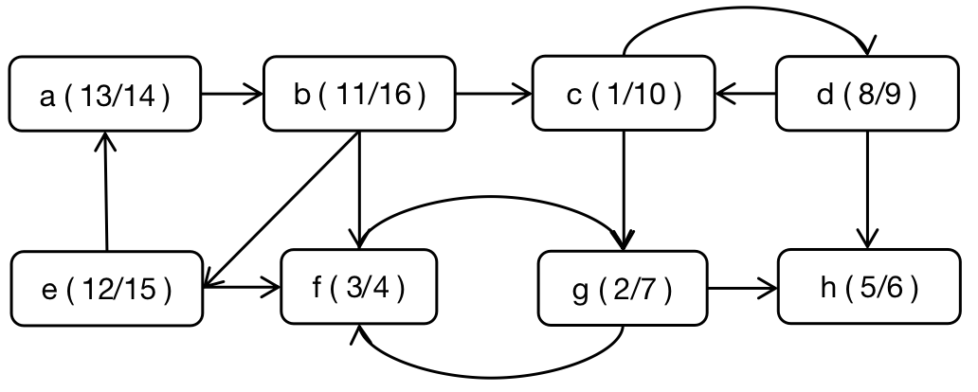

Below is the Reverted Directed Cyclic Graph.

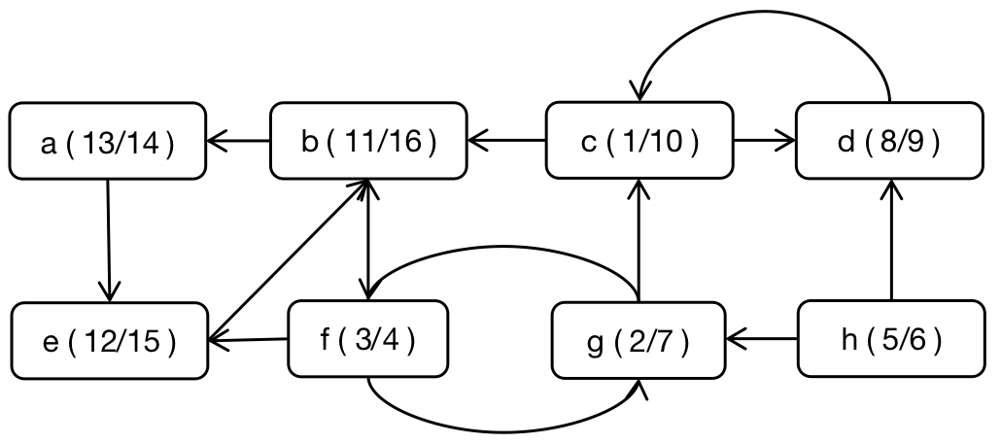

Below is the contraction of Strong Connection Components, and this contraction makes each Strong Connection Components into one node. Then each node can be used to substitute the whole Strong Connection Component.

